U.S. Coast Guard Auxiliary Public Affairs
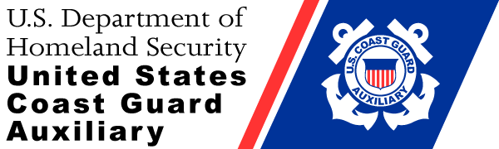
3 May 2017
Contact: Marilyn Aten
Public Affairs Officer
314-607-2069
marilynaten@sbcglobal.net
http://a0850304.uscgaux.info/

News Release

About Boating Safely Course

DATELINE – Flotilla 34 of the United States Coast Guard Auxiliary will be offering the About Boating Safely Class at the Lake Carlyle Visitors Center in the Dam West Recreation Area. Dates are Saturday May 13 & 20, 2017 from 9:00am – l:00pm.

ABOUT BOATING SAFELY
This exciting, in-depth boating safety course will give you knowledge to enhance your boating experience. It will cover general boating terms, boating laws and regulations, boating equipment, navigation rules, locks and dams, operating your vessel safely, anchoring, personal watercraft and so much more.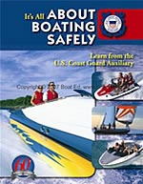

The boating class will give you the knowledge needed to obtain a boat license or safety certification. In Illinois, those born after January 1, 1998 need to have one to pilot a boat. Many boat insurance companies will offer discounts on boating insurance to boaters who successfully complete About Boating Safely.

MATERIALS and COSTS
The ABOUT BOATING SAFELY is a full-color 68 page text book with study guide. A $20.00 fee includes the book, Boating Safely Certificate, Boating Safely Wallet Card and end of course examination. A $5.00 fee for each additional person, after a book has been purchased, includes the Certificate, Wallet Card and end of course examination.

CONTACT TO REGISTER
To guarantee a book and seating, register by contacting Larry Miller FSO-PE eljayem@gmail.com or 618-616-9415. Must be 10 registered to hold the class

