FOR IMMEDIATE RELEASE
March 3, 2017
For more information, contact:
Tanner Aljets
1 Mississippi St. Louis Outreach Assistant
618-462-6802
IL1Mississippi@biodiverse.org

National Campaign Does Local Work In Great River Road Clean Up – more are scheduled and volunteers needed

ALTON—The Nation’s only campaign to help the entire Mississippi River, 1Mississippi, is partnering with Sierra Club’s Three River Project to host a series of Clean Ups along the Great River Road and Metro East roads.

On February 18th, over 40 volunteers picked up more than 90 bags of trash on the Great River Road and Clifton Terrace Road. Interesting items to note included: 31 tires, a mattress, a Wave Runner hull, large chunks of Styrofoam, and a typewriter. The group had the Alton Police Department involved because they came across ten hypodermic needles on the edge of the City. Partnering with the Village of Godfrey and Illinois Department of Transportation was helpful because they set out road safety signs, donated trash bags and safety vests, and removed the trash piles the volunteers put on the side of the Great River Road, including the tires.

“As Spring is nearing, we are reminded of how lucky we are to live in such a beautiful area with caring people. Locals and tourists enjoy traveling the Great River Road and we like to put our best face forward, especially after the grey of winter: a clean bluff line, a trash-free road, and less debris going into our great river. Not only is it more pleasing to look at and safer to bike, walk or drive, but working together helps to establish and reinforce community connections,” said Christine Favilla, Three Rivers Project Co-Coordinator of the Sierra Club.

Volunteers are needed for the following events. Preregistration is encouraged by sending an email to IL1Mississippi@biodiverse.org or at (618) 520-9749 and leaving a message.

:
- Sat, MARCH 18th 8am to 1pm, pitch in for Confluence Trash Bash! In past years, we have had up to 1000 volunteers at once! Most 1 Mississippi and Sierra Club volunteers will be registering for the Old Chain of Rocks location, option one, but you will be with a good crew at any of the sites. REGISTRATION LINK HERE--(Includes a free lunch and T-shirt!).
- Sat, MARCH 11th At 3pm, volunteers are needed at Hellrung Park in Alton for invasive species removal, potato planting, and fun kids’ activities. No RSVP is needed, just show up at the park!
- Sun, March 12th At 9am, River Citizens and Greenway Network will be partnering with USACE at National Great Rivers Museum to work on transplanting native species in order to replace the invasive species removed from Riverlands by other volunteer work.
- Sat, April 29th Two opportunities: Alton Main Street's Citywide Litter Cleanup AND Riverbend Earth Day Festival will both need volunteers!
Alton Citywide Litter Cleanup is from 9-noon, rain or shine. Any questions can be directed towards Sara McGibany from Alton Main Street: sara@altonmainstreet.org .
Riverbend Earth Day Festival 12pm-6pm VOLUNTEERS RSVP HERE. Tasks include parking assistance, vendor check in, shuttle safety, recycling booth attendant, and more! Volunteer shifts are two hours each. We ask that all volunteers attend at least one volunteer orientation. At this time, volunteers will receive an official Festival Volunteer shirt. For questions about the festival, email organizer, acurry@thenatureinstitute.org
Sierra Club office houses the Mississippi River Networks’ 1 Mississippi Outreach Assistant. “River Citizens are the guardians and caretakers of the River; either by clean ups like these or making other small changes in their lives to help protect this national treasure,” said Tanner Aljets, 1 Mississippi Outreach Assistant.

Sierra Club’s Three Rivers Project works closely with MRN to build public support and help establish a national commitment to protect and restore the Mississippi River. “A healthy Mississippi River is something kayakers, fisherman, recreational boaters, duck hunters, and photographers alike need to continue their hobby and livelihoods. Doing a Great River Road Clean up helps with the visual and habitat components,” said Favilla.

The Mississippi River Network (MRN) is a coalition dedicated to protecting the Mississippi River for the wellbeing of the land, water and people of America’s largest watershed. Thousands of everyday people—from mayors to farmers—support the Network’s mission, have signed up as River Citizens and have taken a pledge to act and speak out on behalf of the River. Although you don’t need to be a River Citizen to participate in the clean up, you can become a River Citizen by visiting www.1Mississippi.org.

###
The Mississippi River Network is managed by Bluestem Communications and supported by McKnight Foundation and the Walton Family Foundation. Visit 1mississippi.org for more information.

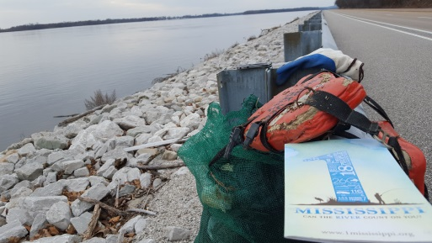Sincerely,
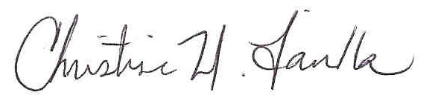

Christine Favilla
Three Rivers Project Coordinator
Piasa Palisades Group of the Sierra Club
Riverbender Community Center
200 W 3RD Street; Suite 512
Alton, IL 62002-6180
(618)462-6802
cfavilla10@sbcglobal.net
http://illinois.sierraclub.org/piasapalisades

