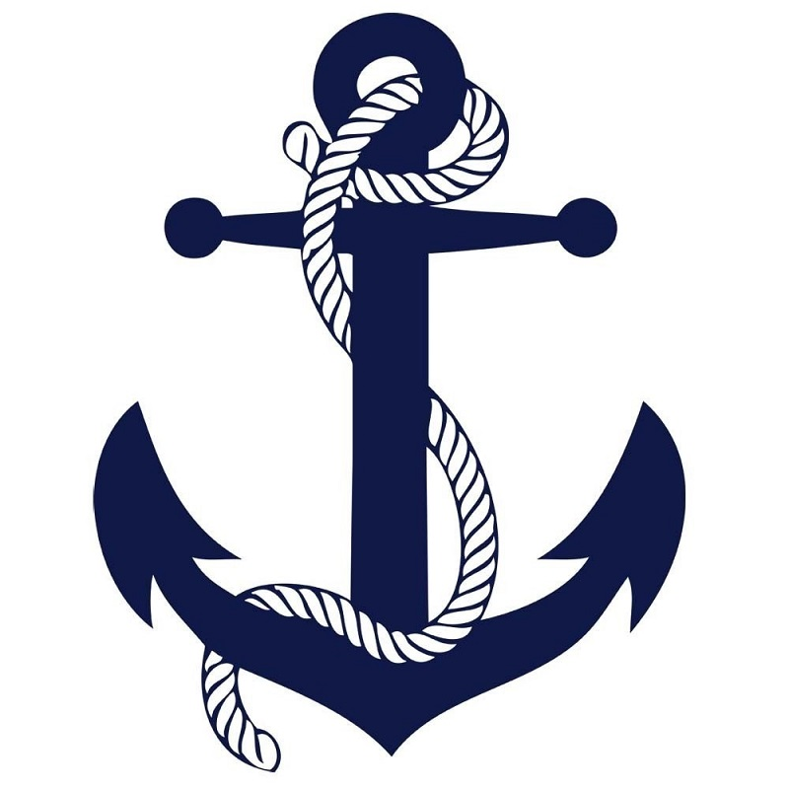Memorial Day Weekend in Grafton
May 23-26, 2014
Make your transient slip reservation NOW! Space is limited!
Call us today to reserve YOUR slip! 618-786-7678
Friday, May 23
River Rambler cruise on the Hakuna Matata 3:00PM – 4:00PM
Grafton Harbor Marina
Parasailing 4:00PM – 6:00PM
Pere Marquette Lodge
Music – “Off the Shoulder” 6:00PM – 10:00PM
The Loading Dock
Music – “Outlaw Express” (Friday Bike Night) 6:00PM – 10:00PM
The Hawg Pit
Music – Open Mic 7:00PM – 11:00PM
Piasa Winery & Pub

Saturday, May 24
Kahuna Fest at Big Kahuna 9:00AM – 5:00PM
BBQ, Beer, and Bands!
Outside on the Marina Grounds
Live Music 2:00PM – 11:00PM
Featuring “Killer Karizma” 7:30PM – 11:30PM on Saturday night and
“Billy Hurst” 7:00PM – 11:00PM on Sunday night!
Grafton Harbor Marina
River Rambler cruise on the Hakuna Matata 3:00PM – 4:00PM
Grafton Harbor Marina
Sunset Cruise on the Hakuna Matata 6:30PM – 8:30PM
Grafton Harbor Marina
Raging Rivers Waterpark opens for the season
Flea Market 9:00AM – 5:00PM
The Loading Dock
Parasailing 11:00AM – 6:00PM
Grafton Harbor Marina
Music – “Ted McCready Duo” 3:00PM – 7:00PM
Grafton Winery
Music – “The Free Corn Dogs” 6:00PM – 10:00PM
Piasa Winery & Pub
Music – “Sonic Tonic” 7:00PM – 11:00PM
The Hawg Pit BBQ Barn
Music – “Killer Karizma” – The Big Kahuna 7:30PM – 11:30PM
Kahuna Fest – BBQ, Beer, and Bands!
Outside on the Marina Grounds
Live Music 2:00PM – 11:00PM
Grafton Harbor Marina

Sunday, May 25
River Rambler cruise on the Hakuna Matata 3:00PM – 4:00PM
Grafton Harbor Marina
Parasailing 11:00AM – 6:00PM
Grafton Harbor Marina
Flea Market 9:00AM – 5:00PM
The Loading Dock
Music – “Billy Hurst” – The Big Kahuna 7:00PM – 11:00PM
Kahuna Fest – BBQ, Beer, and Bands!
Outside on the Marina Grounds
Live Music 2:00PM – 11:00PM
Grafton Harbor Marina
Music – “Strike Force” 1:00PM – 5:00PM
The Hawg Pit BBQ Barn
Music – “Tim Buck Two” 1:00PM – 5:00PM
Piasa Winery & Pub
Music – “Pete Ruthenburg Trio” 2:00PM – 6:00PM
Grafton Winery
Music – “Trilogy” 6:00PM – 10:00PM
The Loading Dock
Monday, May 26 – Memorial Day
River Rambler cruise on the Hakuna Matata 3:00PM – 4:00PM
Grafton Harbor Marina

Parasailing 11:00AM – 6:00PM
Grafton Harbor Marina
Music – “Bistro Blues” 1:00PM – 5:00PM
The Hawg Pit BBQ Barn
Music – “Dave Caputo Band” 1:00PM – 5:00PM
Grafton Winery
Music – “Rusty Groppel” 1:00PM – 5:00PM
Piasa Winery & Pub
Music – “Jim Stevens” 2:00PM – 6:00PM
The Loading Dock

