U.S. Coast Guard Auxiliary Public Affairs
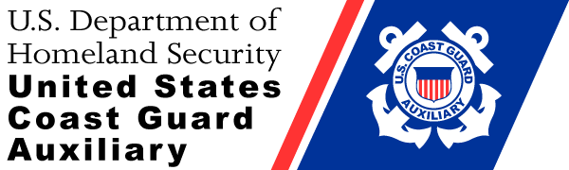

2 June 2016
Contact: Marilyn Aten
Public Affairs Officer
314-607-2069
marilynaten@sbcglobal.net
http://a0850304.uscgaux.info/

News Release
Boating Safely Course

DATELINE – Flotilla 34 of the United States Coast Guard Auxiliary will be offering the About Boating Safely course at the Boat House Restaurant North Shore Marina. It will be held Saturday, June 18 from 8:00am to 4:00pm with a break for lunch. Sign in at 7:45am. There is a cost of $20.00 to purchase a text book and take the end of course examination. Register to guarantee your book by contacting Larry Miller at eljayem@gmail.com or 618-616-9415.

About Boating Safely is a fun and comprehensive boating safety course that covers topics such as Know Your Boat, Before You Get Underway, Navigating the Waterways, Operating Your Boat/PWC Safely, Legal Requirements, Boating Emergencies, and Enjoying Water Sports with Your Boat.

The About Boating Safely course has been approved by the National Association of State Boating Law Administrators. In Illinois and Missouri, successfully completing the course and exam satisfies one of the requirements for obtaining a boater safety identification card. In addition, many insurance companies will offer discounts on boat insurance for passing the course and examination.

For more information about the services provided by the United States Coast Guard Auxiliary, call 314-607-2069 or visit us online at http://a0850304.uscgaux.info/

The Coast Guard Auxiliary is the uniformed civilian component of the U.S. Coast Guard and supports the Coast Guard in nearly all mission areas. The Auxiliary was created by Congress in 1939. For more information, please visit www.cgaux.org
###

