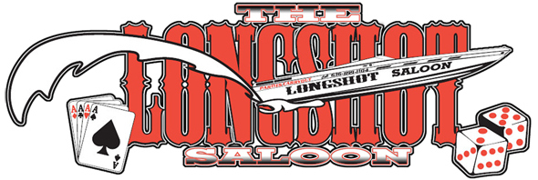

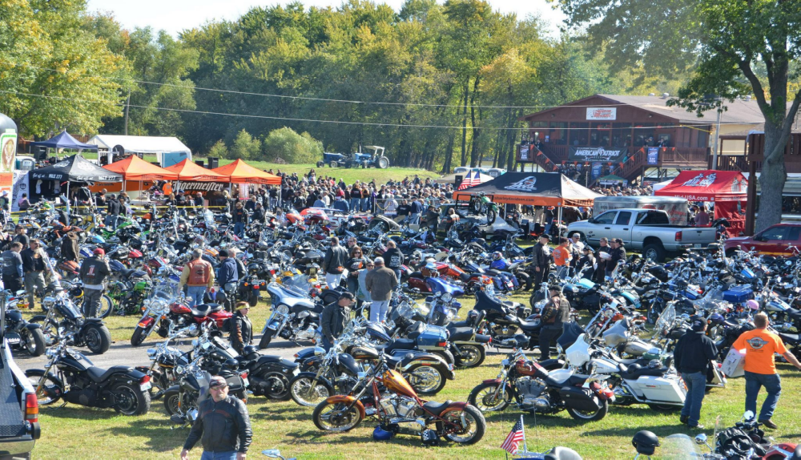

Hours of Operation:

Thursday 11:00am - 11:00pm

Friday 11:00am - 1:00am
Saturday 11:00am - 1:00am
Sunday 11:00am - 11:00pm
(Kitchen closes at 10:00pm – Pizza and Nachos until 11:00pm)

LOCATED AT MY RIVER HOME BOAT HARBOR 212mm

Carry Out Available:
636.899.1104
1545 Riverview Drive
Portage Des Sioux, Missouri 63373
www.MYRIVERHOME.com

APPETIZERS

WHITE CHICKEN NACHOS CHICKEN WINGS
Tortilla chips covered white creamy queso Ten Jumbo wings tossed in sauce
cheese dip, fresh chicken strips, Jerk, Buffalo or Dry
pico de gallo, sour cream and green onion. (Ranch, White Cheddar or Plain)
$4.99 half/$9.99 full $9.99

SEAFOOD FONDUE DOWN SOUTH EGG ROLLS
Lobster, crab, shrimp fondue served Egg rolls stuffed with chicken, mac and cheese,
with homemade croustinis. greens served with a side of brown gravy
$11.99 $9.99

CRAB RANGOON TOASTED RAVIOLI
Five light pastries stuffed with crabmeat and Eight all beef ravioli fried to a golden brown
cream cheese fried to a golden brown and served with our homemade meat sauce for dipping
$5.99 $6.99

SALADS AND FLATBREADS

HOUSE SALAD CAPRESE FLATBREAD
Mixed Greens, cheddar cheese, red onion, Fresh tomatoes, milk mozzeralla cheese
craisins, grape tomatoes, and sugared pecans. fresh julienne basil, salt and pepper
$4.99 $5.99

CAESAR SALAD CHICKEN FLATBREAD
Romaine, Parmesan cheese, homemade Chicken, goat cheese and
croutons with in-house Caesar dressing. sundried tomatoes
$5.99 $9.99

CITRUS SALAD SICILIAN FLATBREAD
Mixed greens, strawberries, madarin oranges, Tomato sauce, four cheese blend,
blue cheese, red onions with citrus vinaigrette pepperoni and salciccia.
$7.99 $9.99

Add Chicken or Shrimp $3

LONGSHOT PIZZA

12” Cheese pizza with your choice of one fresh topping - $8.99

Pepperoni, Sausage, Bacon, Hamburger, Chicken
Green Pepper, Tomato, Mushroom, Black Olive, Onion

Additional toppings $1/each

Specialty Pizza:

Meat Lovers: Sausage, Hamburger, Bacon, and Pepperoni - $12.99

Deluxe: Sausage, Pepperoni, Onion, Green Pepper, and Mushroom - $13.99

SANDWICHES

PHILLY STEAK THE LONGSHOT SHRIMP PO-BOY
Chopped steak, onions, 2 patties, bacon, swiss and Shrimp (fried or grilled),
mushrooms, peppers and cheddar cheese, lettuce, tomato lettus, tomato, remolaude
provolone cheese. onions and pickles. on French baquette.
$9.99 $9.99 $11.99

GROWN FOLKS GRILL CHEESE THE BLACK AND BLUE
Swiss cheese, cheddar cheddar, Blackened chicken breast, crumbled
smoked gouda, pepperjack cheese, blue cheese, lettuce, tomato and red onion.
applewood smoked bacon and tomato. $9.99
$9.99

All sandwiches are served with homemade French fries

*Consuming raw or undercooked meats, poultry, or eggs may increase your risk of food-born illnesses*

ENTREES

STUFFED CHICKEN PAN SEARED SALMON PULLED CHICKEN PASTA
Chicken breasts, sundried tomatoes, Salmon pan seared medium Pulled chicken, sauteed with red onions,
swiss cheese, spinach topped with tarragon dill sauce with spinach, garlic, rosemary, angel hair pasta
with sautéed mushrooms. vegetable of the day tossed in a lemon basil butter and then
$13.99 $15.99 topped with diced tomatoes
$15.99

Served with side salad, loaded mashed potato, and vegetable of the day

FROM THE GRILL

THE SALOON RIBEYE LONGSHOT FILET BUTTERFISH
16oz Ribeye topped with sautéed 8oz Filet topped with goat cheese Whitefish sautéed and
topped onions and mushrooms. sundried tomatoes and lemon basil butter with chili hollandaise sauce.
$23.99 $21.99 $15.99

All entrees are served with a salad and side of your choice. Side options: Loaded mashed potatoes

Homemade French fries

Vegetable of the day

KIDS MENU DESSERTS

All kids items served with homemade French fries Cheesecake of the Week
Kids Burger Bourbon Bread Pudding
Boneless Chicken Bites White Chocolate Cranberry Scone w/fresh berries
Grill Cheese Sandwich $5.99 per slice
Pepperoni Flatbread
$5.99 drink included

DAILY LUNCH SPECIALS

1/2 Sandwich – 1/2 Salad - $6.99 1/2 Burger with Salad - $6.99
(Add $1 for Shrimp Po-Boy)

Add Bacon $1

NIGHTLY SPECIALS

THURSDAY NIGHT TACO NIGHT: $.79 Hard Tacos and $.99 Soft Tacos, Happy Hour from 3:00pm-6:00pm,
$2.00 bottle beer, $1.00 off all premium drinks and $3.00 well drinks
FRIDAY NIGHT FISH FRY: Happy hour from 3:00pm-6:00pm, $2.00 bottle beer, $1.00 off all premium drinks
and $3.00 well drinks

FISH FRY OPTIONS: Tilapia, Catfish or Cod served with French fries, slaw and hushpuppies $11.99

BEVERAGE/BAR OPTIONS

Beverages: $1.75
Pepsi, Diet Pepsi, Dr. Pepper, Sierra Mist,
Unsweetened Iced Tea, Orange Juice,
Cranberry Juice, Pineapple Juice, Coffee
Bottled Water - $2.00

12 OZ. BOTTLE $2.50
Bud Light, Budweiser, Bud Select, Busch, Miller Lite, Coors, Natural Light, Busch N/A

12 OZ. BOTTLE $3.50 – PREMIUM
Shock Top, Corona, Michelob Ultra, Bud Light Lime, Lime-a-rita, Straw-ber-rita

DRINKS: WINE: $5.00

WELLS $4.00 CHARDONNAY

CALLS $5.00 WHITE ZINFANDEL

PREMIUMS $6.00 PINOT
CABERNET
MERLOT
MARTINIS: $5.00 RED VELVET

MARGARITAS: $6.00

FOLLOW US ON FACEBOOK FOR UPCOMING EVENTS AND ENTERTAINMENT

