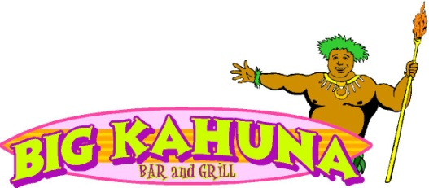

**Entertainment Schedule**

Friday, October 15 - Mixed Nuts

Saturday, October 16 – Street Beat (Grafton Harbor’s Famous Pete Zimmer on the Drums)

Sunday, October 17 – Steve Cline

Friday, October 22 - Plain Label Band

Saturday, October 23 - Midwest Drive

Sunday, October 24 - Ellen Martinez

Friday, October 29 – Nukem

Saturday October 30 - Big Kahuna’s First Annual Halloween Party



Costume Judging and Prizes

Music – Belleville Blues

Book Your Holiday Parties TODAY!!

